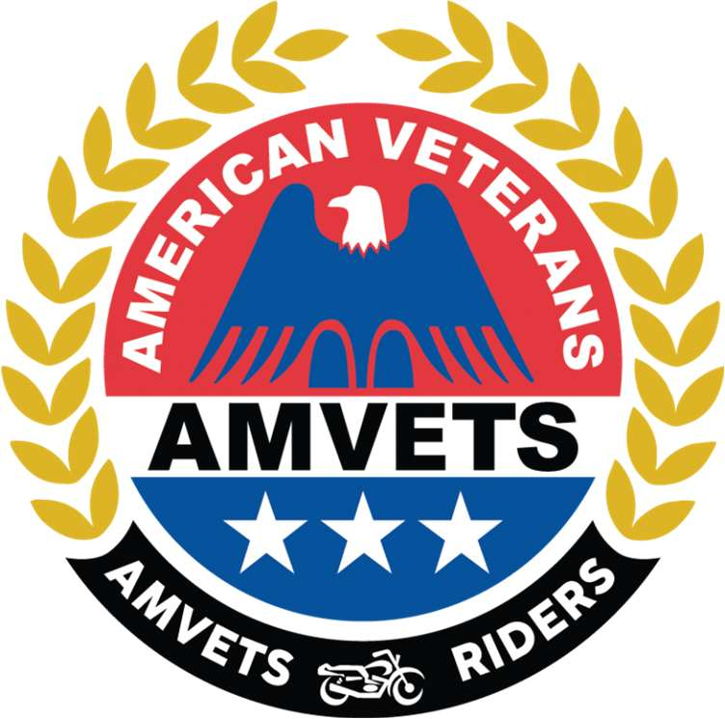
AMVETS RIDERS
CHAPLAIN TRAINING GUIDE
“Riding in Service to Veterans”
Covers:
Duties of the Chaplain • Member Welfare & Support • Deceased Members & Memorial Duties • Key Forms — Death Benefit Request & In Memoriam Certificate • Ceremonial Guidelines & Sample Prayers
Database: amvets-riders-database.web.app
Updated September 2026

1. Introduction
The Chaplain of the AMVETS Riders serves as a spiritual and moral guide for the organization. This manual provides guidance, duties, and resources for carrying out the Chaplain's responsibilities. The Chaplain supports members, families, and communities during times of celebration, challenge, and loss.

Duties of the Chaplain
- Provide invocations, benedictions, and prayers at meetings and events.
- Offer comfort and support during illness, loss, or hardship.
- Conduct and assist with funerals, memorials, and 'Last Chapter' tributes.
- Coordinate with National Chaplain on memorial benefits.
- Maintain dignity and respect in all services.

2. Communication and Coordination
- Send sympathy cards, flowers, or acknowledgments.
- Maintain communication with other Officers regarding member welfare concerns.
- Handle all sensitive information with confidentiality and professionalism.

Chapter and Department distinctions
- Chapter Chaplains focus primarily on direct member contact and local support.
- Department Chaplains provide guidance to Chapter Chaplains and support Department-level activities.

Confidentiality and ethical conduct
- All personal and sensitive matters must be handled with strict confidentiality.
- The Chaplain must act with professionalism, compassion, integrity, and respect at all times.
- The Chaplain shall avoid political, divisive, or discriminatory statements or actions.

3. Meeting and Ceremonial Responsibilities
- Offer opening and closing prayers at meetings when requested by the President.
- Participate in ceremonial events, memorials, installations of officers, and special observances.
- Ensure prayers and remarks are respectful, appropriate, and inclusive of all members.

Member welfare and support
- Maintain awareness of members who are sick, hospitalized, injured, or experiencing hardship.
- Reach out to affected members and families to offer support and encouragement.
- Coordinate with the President or Executive Board when additional assistance or outreach is needed.

Deceased members and memorial duties
- Maintain a record of deceased members for the Chapter or Department.
- Assist in organizing memorial services, moments of silence, or other recognition.
- Ensure deceased members are properly acknowledged at meetings or official gatherings.

4. Key Forms and Responsibilities

Death Benefit Request Form
The Death Benefit Request Form must be completed to request Rider memorial recognition. Submission requires an accompanying obituary or funeral notice. Upon receipt of the completed form and required documentation, the AMVETS Riders Family will receive a $250.00 memorial benefit check.
The form is available on the National AMVETS Riders website or can be found in the Appendix B section of this document.

In Memoriam Certificate
An official certificate issued in tribute, honoring the Rider's service, dedication, and commitment to the AMVETS Riders.

5. Ceremonial Guidelines
The following are examples of prayers that may be used by the Chaplain:

Sample invocation
Heavenly Father, we thank You for bringing us together in the spirit of service, loyalty, and brotherhood. Bless this gathering, guide our thoughts and decisions, and help us always remember the veterans, families, and communities we serve. Grant us wisdom, courage, and compassion in all that we do. Amen.

Sample benediction
May the Lord bless and keep us as we leave this gathering. May our work reflect honor, our service reflect love, and our lives reflect loyalty to our Riders, our veterans, and our country. Go forth in peace, remembering those we serve and those who have gone before us. Amen.

For regular meetings
Invocation (Opening Prayer)
Heavenly Father, we gather today as AMVETS Riders, grateful for the freedoms we enjoy and the Veterans who secured them. Guide our decisions with wisdom, unite us in purpose, and bless our efforts to serve veterans, their families, and our nation. Amen.

Benediction (Closing Prayer)
Almighty God, as we conclude our meeting, we thank You for the fellowship and shared commitment to our veterans. Watch over us as we depart, grant safe journeys home, and inspire us to carry forward the spirit of service and sacrifice. May Your peace and grace remain with us. Amen.

For ceremonies — customize to fit your ceremony
Invocation (Opening Prayer)
Gracious God, on this occasion we come together to honor service, leadership, and patriotism. Bless this ceremony with Your presence, guide our words and actions, and remind us of the sacrifices that make our freedoms possible. Strengthen those who serve today and comfort those who have given so much. In Your holy name, we pray. Amen.

Benediction (Closing Prayer)
Almighty Lord, we give thanks for the Loyalty, Respect and Brotherhood celebrated here. As we part, bestow Your blessing upon us: grace to the living, rest to the fallen, peace to our nation, and courage to continue serving those who served. Go with us now and always. Amen.

For memorial services
Invocation (Opening Prayer)
Eternal God, we assemble in solemn remembrance of our fallen Riders. Lord, You comfort those who mourn, heal the wounds of loss, and help us honor their sacrifice through lives of gratitude and service. May their memory inspire us to uphold the values of loyalty, respect and brotherhood. Amen.

Benediction (Closing Prayer)
Merciful Father, as we conclude this memorial, we entrust our departed brothers and sisters to Your eternal care. Grant them rest and peace, console their loved ones, and unite us in grateful remembrance. Bless our nation with harmony, and may the light of their example guide us forward. Go in peace, and may God be with us all. Amen.

Appendix B: Death Benefit Request Form
Note: Reproduced from the source guide. Complete the form and submit it with the required obituary or funeral notice as described in Section 4.
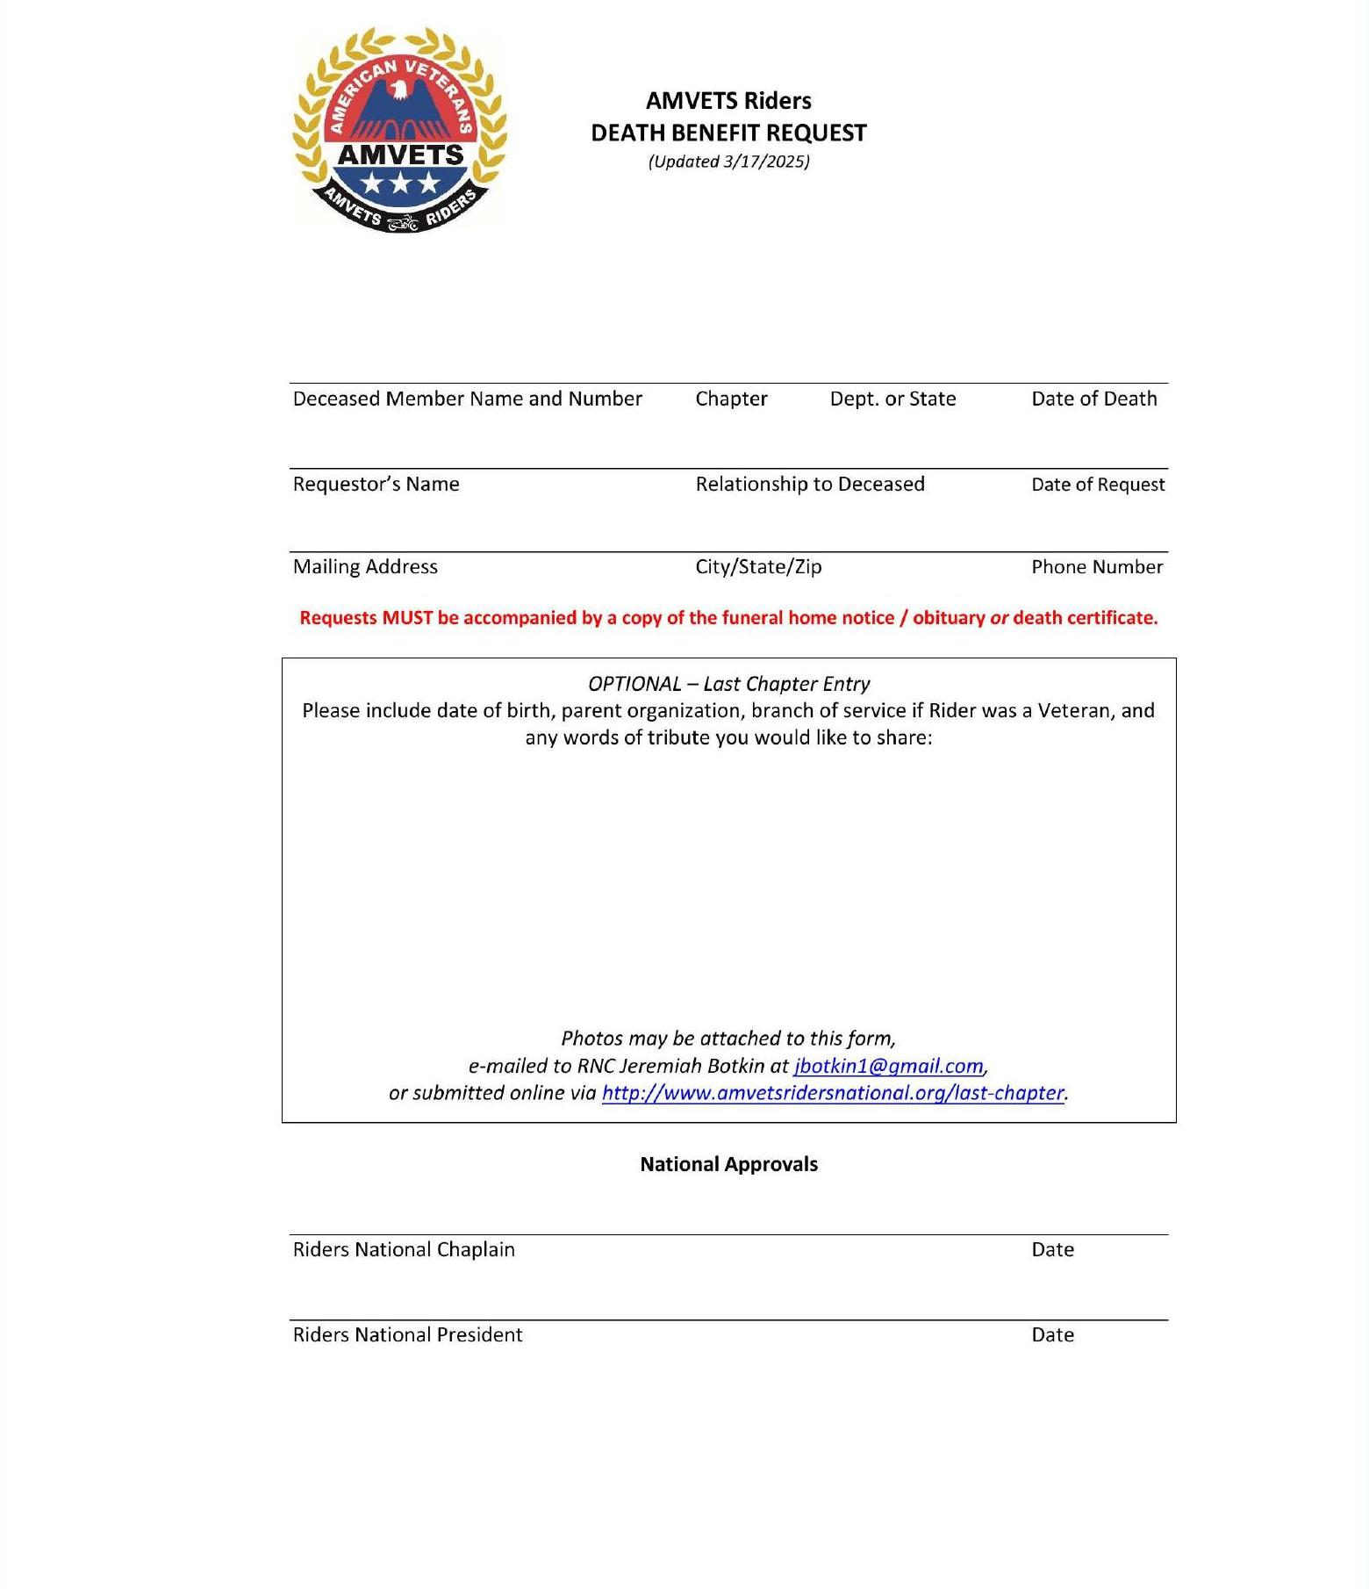

Appendix C: In Memoriam Certificate
Note: Reproduced from the source guide as the official AMVETS Riders memorial certificate design.
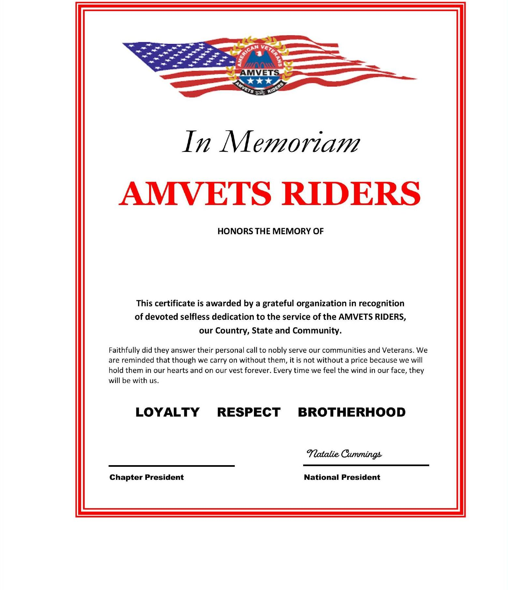

Closing Statement
The Chaplain plays a vital role in supporting the heart of the AMVETS Riders organization — its members.
Through compassion, service, and leadership, the Chaplain helps ensure that no Rider stands alone.
Loyalty – Respect – Brotherhood

