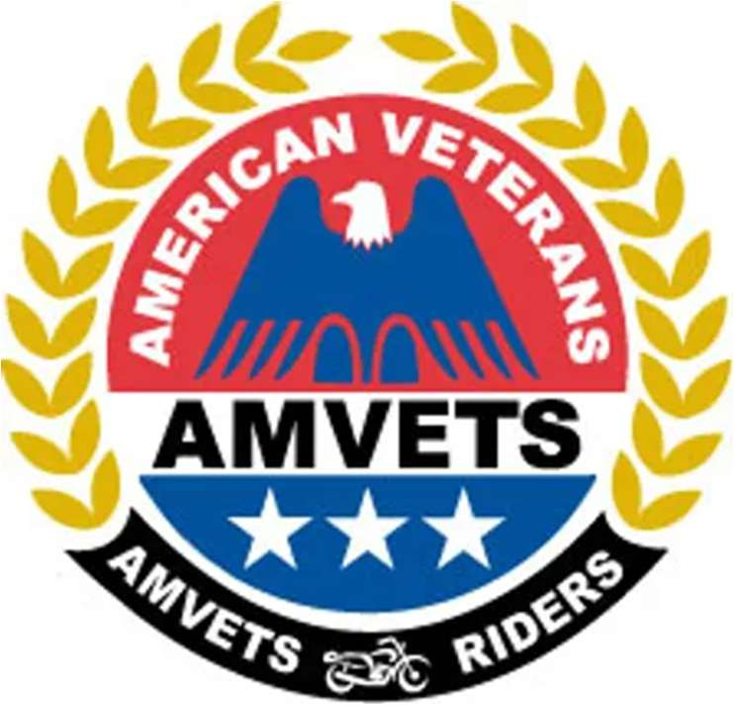
AMVETS RIDERS
ROAD CAPTAIN TRAINING GUIDE
“Riding in Service to Veterans”
Covers:
Mission Statement • Qualifications & Requirements • Duties of Head Road Captain • Equipment • Leading or Assisting in a Chapter Ride • Staging a Group Ride • Securing an Accident Scene • Riding Formation & Group Riding Safety • Hand Signals • Injury Report & Road Captain Application
Database: amvets-riders-database.web.app
Updated September 2026

Mission Statement
- The mission of the AMVETS Riders Road Captains is to ensure that all rides and events are well planned, safe, and enjoyable.
- We will fulfill this commitment by focusing on all aspects of safety, particularly traffic and crowd control.
- The AMVETS Riders Road Captains will also assist the Chapter with other issues when requested.
- All AMVETS Riders Road Captains will treat all participants of events with the same respect, as you would expect for yourself.
- All Road Captains will react in a positive and professional manner when responding to any problems.

General
Being an AMVETS Riders Road Captain is a “privilege.” These qualifications, requirements, and rules to become an AMVETS Riders Road Captain were set forth by the National AMVETS Riders Head Road Captain/Safety Officer. These qualifications, requirements, and rules are in place for the Road Captains (RCs) and Assistant Road Captains (ARCs) within each Chapter of the AMVETS Riders.
- All new applicants to be a Road Captain will serve as an Assistant Road Captain for the entire calendar year. If you meet the requirements at the end of the year, you may become a full Road Captain.
- All Road Captains will be acknowledged at the December meeting or at the end of the riding season, if they fulfill the participation and rules set forth in this manual.
- There will be an RC meeting every month unless otherwise announced by the Head Road Captain.
- RCs and ARCs will lead and assist in Chapter rides, assuring that, as much as possible, the rides are well laid out, pre-ridden, and made as safe as possible for those attending. Other duties may include, but are not limited to, parking detail or assisting in special Chapter-sponsored events.
- The main responsibility and priority of all RCs and ARCs is safety at all times for all riders attending Chapter rides and events.
- All RCs and ARCs will set forth good examples for those attending Chapter rides of safe group riding practices and procedures.
- New applicants will be interviewed before they are accepted as an assistant.
- If you are a current Road Captain and you lose your license or insurance and you don't notify the Head Road Captain, and he finds out on his own, you will lose your status as a full Road Captain.
- All RCs and ARCs will become completely familiar with and adhere to the rules and requirements set forth by the National AMVETS Riders Head Road Captain/Safety Officer.
- The Head Road Captain will review each application. If there is any question as to the qualifications of an applicant, the following officers will make the final decision on acceptance: Head Road Captain, Safety Officer, and President.
- Any violation of the qualifications, rules, and requirements are grounds for dismissal of the “privilege” to be a Road Captain. The decision of a dismissal will be determined by the Head Road Captain, Safety Officer, and President.

Clarifications

Assisting in a Chapter ride
Any RC and ARC attending any Chapter ride may at any time be asked to lead a group of riders, assist a rider with mechanical problems, or help in any other capacity during any ride. Because an RC and ARC may be asked to perform any duties during a ride they attend, they will be credited with having assisted in that ride.
Note: If you assist in a ride, contact the Head RC or any Chapter Officer and have them sign you in as assisting.

Mentoring
An RC teaching (mentoring) an ARC in learning how to set up, lead, anchor, sweep, and manage a Chapter ride is accomplished either by the ARC working with an RC on the RC's ride, or an RC working with an ARC on the ARC's ride. With that said, all RCs should help in teaching other RCs proper techniques in riding.

Approving / pre-ride a Chapter ride
This is the duty of the HRC — to do pre-rides to ensure that the route laid out by the Ride Chair is accurate and safe as possible. More than one RC may attend a pre-ride; this is encouraged since this puts more eyes on potential problems. Approving or laying out a Chapter ride shall include, but not necessarily be limited to:
- Verify the maps and written routes given by the Chapter Ride Chair.
- Checking out and checking assignments for gas stops, restaurant stops, rest stops, points of interest stops, and hotel/motel stops. There may be other issues to be looked at on a case-by-case basis.
- Pre-riding (at the very least, one pre-ride) the entire route. It is recommended that the ride is pre-ridden as many times as possible to become completely familiar with the route. However, it may not be practical to pre-ride longer rides in their entirety (i.e., a Chapter ride that lasts two or more days).

Qualifications for All Road Captains
The following is a list of requirements that all RCs are expected to accomplish throughout the calendar year in order to maintain their status as RC for the AMVETS Riders.
- Valid driver's license with motorcycle endorsement (if required within your State).
- Valid motorcycle insurance for the motorcycle you participate with.
- A member of the AMVETS Riders.
- Complete an MSF-sponsored Advanced Riders Safety Course within one year.
- Complete a Basic First Aid Course within one year (American Red Cross preferred).
Zero tolerance — RCs will not partake in or consume any kind of alcohol or drugs prior to or during the time they are acting in the position of Road Captain during an event.
- Follow the instruction of the Head RC and Assistant Head Road Captain.
- RCs will operate their motorcycle in a safe manner.
- If you observe a ride participant with a motorcycle that could present a safety hazard to the rider or any ride participant, contact the Head RC or the Safety Officer.
- Do not challenge the rider of a motorcycle by yourself; try to contact the Head RC or the Safety Officer first. If they are not available, at least get another RC or ARC to help you. They are your witnesses.
- Treat all ride participants with the same respect that you would expect to be treated.

Road Captain Requirements
The following is a list of requirements that all Road Captains are expected to accomplish throughout the calendar year in order to maintain their status as Road Captain for the AMVETS Riders.
- Attend at least 2 or more Chapter rides.
- Attend at least 1/2 of all RC meetings.
- Attend at least 1/2 of all Chapter meetings.
- Assist in at least 25% of advertised pre-rides.
- Assist in at least 50% of Chapter rides requiring RC support.
- Although not mandatory, it is strongly encouraged that RCs mentor/assist an ARC on rides that require RC support. The intent is to ensure that RCs and ARCs have an opportunity to learn good group riding skills.
- Report to your Team Leader at each event, at the appointed time.
Go to your assignment, which could include any of the following and possibly some not listed:
- Help with set-up of things.
- Crowd control.
- Traffic control.
- Watch for safety issues, both on motorcycles and participants.
- Help ensure that participants have an enjoyable and positive event.
- Any other request from the Head Road Captain to promote a good event.
- Stay at your assignment until you are replaced or released from the assignment.
- RCs must wear safety equipment specified by the Head Road Captain and/or Safety Officer.
- Always be alert for safety concerns for all riders and motorcycles.
If there is an accident — Make sure that the scene is secured (see Securing an Accident Scene). At least 2 and up to 4 RCs should stop with the accident. The other RCs should make sure that all motorcycles not involved in the accident proceed to a safe location, selected by the RC on the scene. The Safety Officer should proceed to the accident if on the ride. Pictures will be taken and the information needed for the AMVETS Riders accident report will be gathered. A copy of the AMVETS Riders Injury Report is in the Appendix — each RC shall keep a copy of this form with them on all Chapter rides.
It is understood that the position of Road Captain is a volunteer position and that all of us have families and personal lives apart from the AMVETS Riders Chapter. There may come a point where you are not able to fulfill the above requirements. This will never be viewed as a reflection of your commitment to the position of Road Captain or the AMVETS Riders. Please contact your HRC/AHRC and let them know if your duties as RC need to be put on hold for a while. Your cooperation will be greatly appreciated.

Assistant Road Captain Requirements
The following is a list of requirements that all Assistant Road Captains are expected to accomplish throughout the calendar year in order to maintain their status as Road Captain for the AMVETS Riders.
- Attend at least 2 or more Chapter rides.
- Attend at least 1/2 of all RC meetings.
- Attend at least 1/2 of all Chapter meetings.
- Assist in at least 25% of advertised pre-rides.
- Assist in at least 50% of Chapter rides requiring RC support.
- Adhere to the RC rules and requirements.

Duties of Head Road Captain

Head Road Captain
The Head RC is the primary officer in charge of the RCs. The Head RC will:
- Attend the Chapter meetings.
- Be in charge of the RC meetings.
- Assign group events.
- Work closely with and assist the RCs and Assistants.
- Distribute equipment.
- Review all rides.
- Ride in pre-rides.
- Work with the Ride Chairpersons and Activities Officer.
- Assist with obtaining help from local police departments on events.

Assistant Head Road Captain
- Work closely with and assist the Head Road Captain.
- Take charge in the Head Road Captain's absence.

Equipment for the Road Captains

Road Captain orange T-shirt
Each Road Captain will receive the AMVETS Riders Road Captain T-shirt. You are expected to wear this shirt when the Head Road Captain or his designee has decided to wear the shirt for the event.

Road Captain orange traffic vest
Each Road Captain will receive the AMVETS Riders Road Captain vest. You are expected to wear this vest when the Head Road Captain or his designee has decided to wear the vest for the event.
Vest return policy — Vests will be distributed and accounted for. When your Road Captain duties end, you are requested to return the vest. If you don't return the vest, you will be charged $40.00 for the cost of the vest.

Road Captain cameras
Each Road Captain will receive a camera from the Head Road Captain or the Assistant Head Road Captain. These cameras should be taken with you when you are on an event. They should be used in an emergency situation — use these cameras to take pictures of accidents that involve Chapter events.

AMVETS Riders Accident Report
Each Road Captain will receive a copy of this report. The information should be obtained and this report should be filled out when an accident has occurred during a Chapter event. Give the completed form to the Safety Officer and Head Road Captain.

Leading or Assisting in a Chapter Ride
The following is a list of items to be accomplished when leading or assisting during a Chapter ride that requires Road Captain support.
- If this is a group ride, the Head RC or Assistant Head RC should provide the Ride Chair a copy of the “Group Riding Criteria” hand-out to pass out to all who sign up.
- If at all possible, all Chapter rides should consist, at the very least, of one HRC or AHRC and another RC or ARC with route documentation.
- Understand the mapped and written documentation given by the Ride Chair thoroughly.
- All intended leaders of a Chapter ride shall pre-ride the entire ride (at the very least once), as close as possible to the actual ride date, to identify any road construction (which may require a change in route) and safety hazards.
- Ensure that all attending/assisting RCs and ARCs have a copy of a map or written route in case they would be required to take the lead for some unforeseen reason.
- Make it a point to introduce yourself to new members or persons attending the ride you have never met before. This is intended to make new attendees feel welcome and help them feel comfortable around a group of people they have never met.
- If a Chapter ride is well attended, it may be required to keep the group to a more manageable size. If this is the case, the lead HRC/AHRC on the ride will appoint other RCs or ARCs (preferably those familiar with the route) to lead, anchor, and/or sweep the newly created group (see Staging a Group Ride below).

Pre-ride orientation
Provide a pre-ride orientation that shall include the following:
- Explain the entire ride and/or destination — gas stops, points of interest, etc.
- Go through hand signals and stress the importance of relaying hand signals. Hand signals will include: left turn, right turn, pointing out road hazards, single file, return to staggered positions, slow down, stop, and speed up.
- Explain staggered riding formation and the importance of maintaining staggered formation and distance intervals.
- When a ride consists of interstate highway riding, explain how the interstate will be handled.
- Introduce all attending/assisting RCs and ARCs. Explain what their duties will be on the ride.
- Make it a point to ask for people who are new to group riding so that they can be placed in their own group. Explain what happens in case a bike in the group has a mechanical breakdown or an accident occurs.
- Explain that although the RCs and ARCs are there to make the ride as safe as possible, all riders attending the ride are ultimately responsible for their own safety and judgment (e.g., going through a stop sign after the leader has cleared the intersection).
- Ask if there are any questions.

Group riding practices
- Place the most inexperienced rider in the back of the group with their own anchor and sweeper, if possible. Always keep in mind that some riders in your group may not be as accomplished as you are — do not ride/lead beyond the means of the least experienced rider in your group.
- When coming to a stop sign, stop completely and allow all riders in the group to catch up with the lead bike and stop with everyone else. Once all riders have stopped, continue through the stop sign when it is safe to do so.
- Do not ride faster than the posted speed limit.
- Do not ride any slower than absolutely required. Riding too slow presents an extreme hazard because the group is riding too slow and a car attempts to pass the entire group of riders on a two-lane road.
- Do your best to keep the group together. Provide a means to re-group if riders get separated during a ride.
- Do not lead your group to pass a slow car on a two-lane road unless you are absolutely certain the entire group can make the pass with plenty of room to spare and in a safe manner. It is better to arrive late than risk the safety of the entire group — it's just not worth the risk!
Interstate riding — When riding on an interstate highway, be aware of cars that may need to merge into the group to make an exit. Provide room for the car to merge into the group and exit. Most cars do not like to ride in the middle of a group of motorcyclists and will move out of the group as soon as possible. Provide this information to all riders at the pre-ride orientation if the ride includes interstate riding. It is up to the RCs and ARCs to set a good example for the entire group — you are representing the entire AMVETS Riders Chapter. Do not allow yourself to be under the influence of or consume alcohol or drugs when leading or attending/assisting in a Chapter ride.
People who attend our rides are counting on us as RCs and ARCs to provide a fun and safe experience. Being under the influence of any substance, including some prescription drugs, can alter your judgment.
- If there is someone in your group causing a hazard to themselves or those around them, take them aside or pull up next to them and ask them to stop doing whatever it is that is causing the hazard. If you need to approach someone in the group who is causing a hazard, be sure to have at least one or more RCs and/or ARCs accompany you. If the person continues to present a hazard and refuses to listen and heed your request, kindly give them a copy of the route and tell them to ride by themselves to the destination or leave the ride completely. This is a right as an RC or ARC for the AMVETS Riders Chapter — we'd rather have someone mad at us than have someone else injured or worse!

Staging a Group Ride
The HRC/AHRC will appoint other RCs or ARCs at desired positions per the groups listed below. These positions will be assigned according to the route and size of the group. The positions are divided as follows: HRC or AHRC, Blocking RCs, Group A Anchors (experienced riders), Group B Anchors (average riders), Group C Anchors (new riders), Group D Anchors (trikes, sidecars, and others), Drag RCs, and Support Vehicle.

Blocking RCs
Blocking RCs will follow the direction of the HRC. When the HRC gives a signal to go ahead of the group and block an intersection, this rider (or riders) should maintain their position until the Drag Bike RC relieves the blocking rider. At this point the rider should have rejoined the group in front of the Drag Group. While traveling, the RCs will stay grouped at the rear once they have performed a block, unless otherwise directed. Only if the opportunity occurs should the Blocking RCs go ahead of all the groups and rejoin their RC group in front.

Group (A) Anchor — Experienced Riders
The riders in this group should be riders who have ridden in group rides in the past. The RC Anchors assigned to this group should watch the riders in this group to the best of their ability. If they see a rider who doesn't seem to fit in this area, it is okay to show your concern and ask the rider to consider going to a different group. If the rider doesn't want to move to a different group and you see it as a problem, go to the Head RC to work this out.
The Anchor position of all groups will be in the front lead position of their group and shall never leave this position. The Anchor of Group A will stay in the lane position directly behind the HRC's group, and the anchors of the other groups will follow accordingly. The Anchor is to maintain a constant speed for the group and maintain a safe distance from the group in front of them while traveling the main highways. If the need arises, the Anchors should speed up, slow down, or let traffic pass in front of their position.

Group (B) Anchors — Average Riders
Guidelines in Group A apply here also. The only difference is that the riders in this group may be a little less comfortable or experienced in the group-riding atmosphere. (Refer to Group A for duties during the ride.)

Group (C) Anchors — New Riders
Guidelines in Group A apply here also. The riders in this group would be the ones who have never ridden in a group ride before or are new to motorcycling. (Refer to Group A for duties during the ride.)

Group (D) Anchors — Trikes, Sidecars, and Others
Guidelines in Group A apply here also. The reason for this group is that trikes and other similar bikes don't work well in staggered formation. (Refer to Group A for duties during the ride.)

Drag RCs
- The Drag RCs are to make sure the entire group stays together.
- Block the passing lane for the group.
- Should a bike break down or an accident occur, one of the Drag RCs should stop with the bike and make sure the Support Vehicle has stopped also. Contact with the Team Leader will be made to determine what course of action needs to be taken.

Support Vehicle
The Support Vehicle (SAG Wagon) should be the last in the group. The SAG Wagon follows the route and is either directly behind the Drag Anchor RC or as close to the Drag Anchor RC as possible.

Securing an Accident Scene
- If there is an accident in a Chapter event, make sure that the scene is secured.
- At least 2 and up to 4 RCs should stop with the accident.
- The other RCs should make sure that all motorcycles not involved in the accident proceed to a safe location.
- This location will be selected by the Head RC or RC in charge.
- The Safety Officer and Head RC should proceed to the accident if they are on the ride.
- RCs at the scene should park their motorcycles off the roadway.
- If the roadway is blocked, an RC should proceed down the road a distance so they can warn other drivers to slow down and to prevent another accident. If you have any warning devices such as flares, lights, and/or flags, please use them.
- Call 911 — you should know the emergency numbers of each state that you travel through.
Care of the injured — After the above is done, an RC should go to the injured. Do not move them. Do not remove their helmet. If there is bleeding, you can apply pressure. You should wear protective gloves if there are any body fluids.
- Someone should make sure that all crashed motorcycles are not running and that the ignition is turned off.
- Have all witnesses go to a location off of the roadway; get their name, address, and phone number. Ask them to wait for the police to arrive.
- Pictures will be taken and the information needed for the AMVETS Riders accident report will be gathered. (A copy of the Injury Report is in the Appendix and each RC will receive a copy.)
- When the police arrive at the scene, they will take over, unless you are asked to assist.

Riding Formation

Staggered riding
- The lead motorcycle should be in the left 1/3 of the lane; the second motorcycle should be in the right 1/3 of the lane, one second behind the first rider, and so on.
- Leave enough room between each motorcycle so that any rider can maneuver to the right or left without hitting anyone else.
- Always stay in line with the bike in front of you. Do not switch between the left and right side of the lane.

Single file riding
All motorcycles ride in a single line, two seconds behind one another, in either the right or left third of the lane. The lead rider determines on which side of the lane the group will ride.
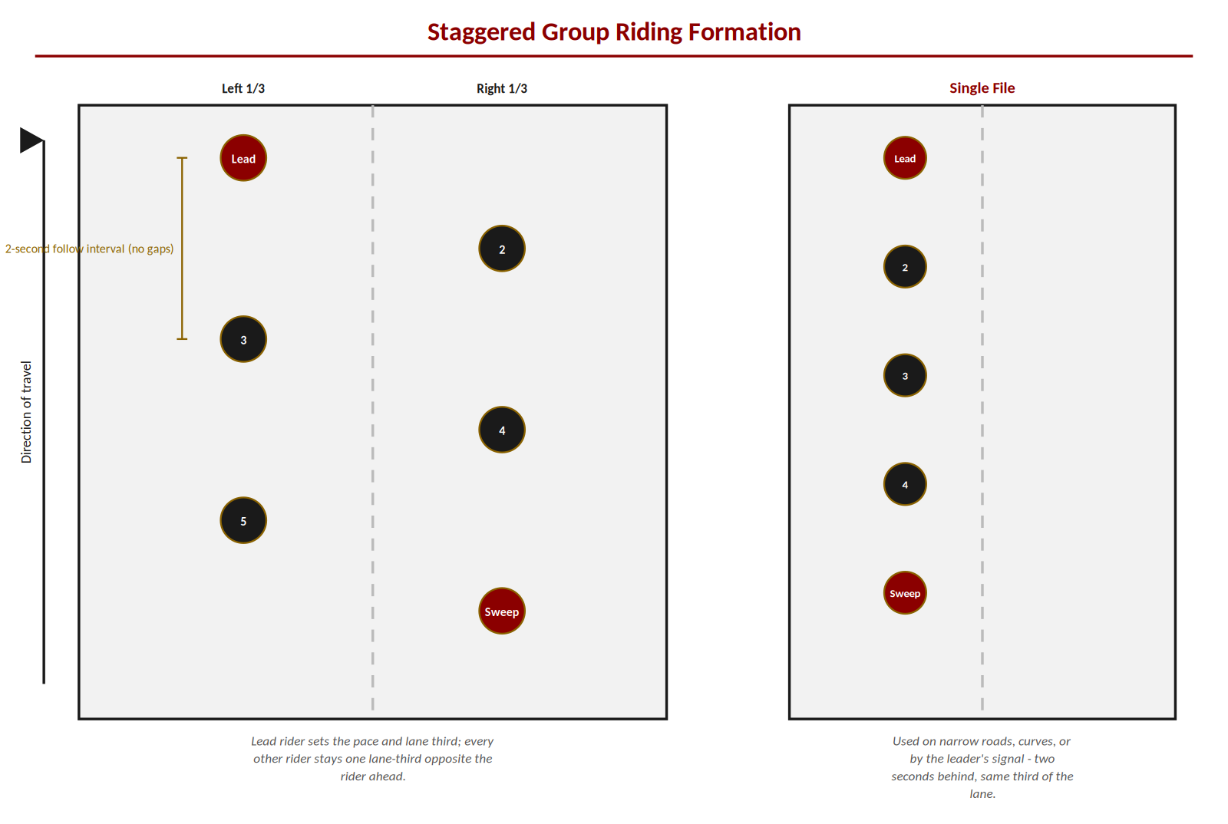
Note: Redrawn for this guide — an original schematic, not reproduced from any outside source.

Group riding tips (slow start)
Question: If you immediately pull out onto the street and accelerate up to 55 mph, how much time will pass before the last bike — which is nineteen bikes behind you — starts to move? If there aren't any other vehicles on the road and the riders manage to follow you exactly two seconds apart, the last bike will be sitting in the same spot for 38 seconds. At 55 mph, you'll be 3,078 feet down the road before the last bike even eases out the clutch. What's more, if you maintain 55 mph, each following rider will have to go faster than 55 to catch up with you. If the last bike throttles up to 110 mph, he can catch up to the group in maybe 30 seconds. If the last bike is willing to risk only 80 mph, it will take him about a minute and a half to catch up, assuming you hold 55 mph. So you shouldn't be surprised if the last rider is approaching meltdown long before the lunch stop.
Think of a group of motorcycles like a train, with the cars hitched together by 1-foot bungee cords. That's why a sharp ride leader pulls out slowly and creeps along at 30 mph or so until the last bike gets rolling. Once the entire group is rolling, you can pick up the pace to cruising speed. To avoid holding up other motorists, it's wise to maintain at least the speed limit or the average speed of traffic if the road is busy. You don't want to encourage other motorists to attempt passing the group two or three bikes at a time.
When approaching a slower speed zone, a clever leader decelerates the group well before the speed sign, so that as the first bikes arrive in the slower zone, the last bike has also slowed and doesn't have to stand his bike on the front wheel to avoid jamming it into someone's muffler.

Group riding safety tips
- When in a tight curve, the rider on the outside of the curve is required to give room to the rider on the inside, in case the curve is too tight to negotiate at speed without excessive crowding.
- Know the stopping power of your motorcycle. Seventy percent of the stopping power is in the front brake. Don't coast to a stop — hit the brake so everyone behind you knows you are slowing down or stopping.
- Maintain a constant speed. This helps prevent the “rubber band effect.”
- Always keep the group tight without crowding each other. Stay close through intersections and traffic lights so the group doesn't get divided.
- If there is a vehicle that has to get onto or exit the freeway, let that vehicle through and then close the gap as quickly as possible afterward.
- Never ride in someone's blind spot.
- Remember, on a two-lane highway, if the lead bike passes, everyone passes as if they are riding alone. Just because the bike in front of you passes does not mean it is okay for you to pass.
- SEE — Search - Evaluate - Execute.
- Staggered Formation — 2-second rule no matter the speed (no gaps).

Appendix A: Hand Signals
Note: Reproduced from the AMVETS Riders hand signals reference (RCHANDSIGNALS2008) — the same chart used in the source safety manual, cleaned up for legibility.
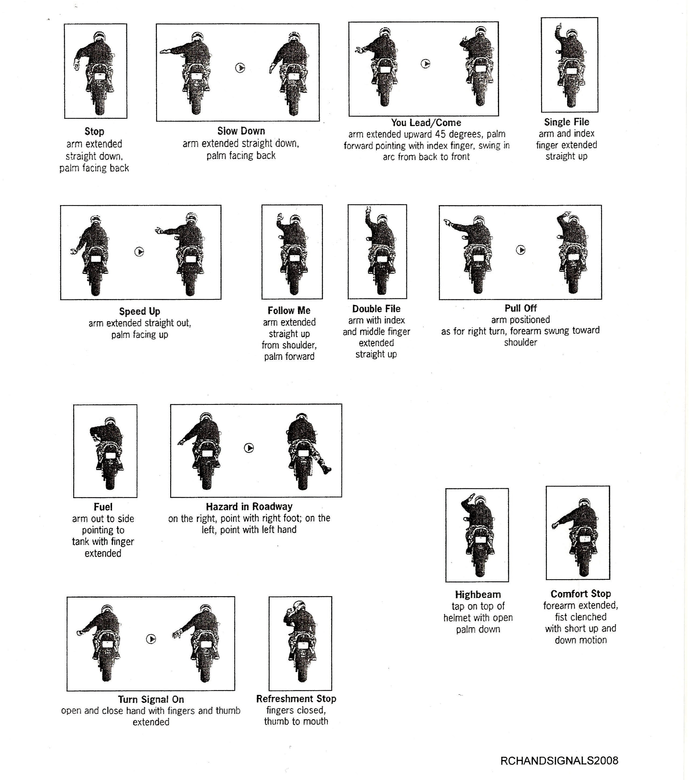
Safety first — Only give a hand signal when it is safe to remove a hand from the bars. If conditions do not allow a signal, maintain control of the motorcycle first.

Appendix B: Injury Report Form
Note: Reproduced from the source manual as a ready-to-use template. Each Road Captain should keep a copy of this form on all Chapter rides.
Chapter Name: _______________________________ Chapter Number: _______________________
Reporting Chapter Officer Name: _______________________________________________________
Home Ph: _______________________________

Mailing Address: _______________________________________________________________
Work Ph: _______________________________
Best time to call: _______________________________
Chapter Insurance Certificate #: _______________________________
Date of Injury: _______________________________
Place of Injury: _______________________________

Name, address, and age of person(s) injured: ___________________________________________
_______________________________________________________________________________

Names, addresses, telephone numbers of persons who saw the incident (attach extra sheets if necessary):
_______________________________________________________________________________
When, where, how the injury occurred (attach a separate sheet if necessary):
_______________________________________________________________________________

Type of injury (check appropriate areas)
Fatal ____ Head ____ Neck ____ Internal Injuries ____ Amputation ____
Back/Spine ____ Arms ____ Legs ____ Other ____

Name, address, phone number of person(s) having pictures of the accident scene:
_______________________________________________________________________________
Name, address, phone number of responding police department and complaint #:
_______________________________________________________________________________

Note: Attach a photocopy of each injured person's signed release form (required). Attach the police report if available. Only police should take witness reports.

Appendix C: Road Captain Application
Note: Reproduced from the source manual as a ready-to-use template. Return the completed application to the Head Road Captain at a Road Captains meeting.
Calendar Year Applying For: _______________ Date: _______________
First Time Applicant: Yes / No
Returning Road Captain: Yes / No
Apprentice Road Captain Last Year: Yes / No

Name: _______________________________________________________
Address: _______________________________________________________
City, State, ZIP: _______________________________________________________
Home Phone: _______________________________
Alternate Phone (cell): _______________________________
E-mail: _______________________________________________________

Driver's License: Yes / No Motorcycle endorsement: Yes / No (attach copy of license with this document)
Current Motorcycle Insurance: Yes / No Insurance Company: _______________________________
Note: Attach a copy of a valid insurance card with this document.
I authorize AMVETS Riders (Head Road Captain and Officers) to check the status of my motorcycle license and insurance.

Motorcycle riding experience in years: _______________________________
Attended & passed Motorcycle Safety Course: Yes / No
Name of Course: _______________________________ Location: _______________________________
Date: _______________________________
Note: Attach a copy of certificate/card (with supporting dates) to this application.
Do you ever ride 2-up: Yes / No — if so, how often: _______________________________
T-Shirt Size: You _______________ Passenger _______________

Signature: _______________________________________________________
Return to Head Road Captain at a Road Captains meeting — Don't forget to attach: driver's license, insurance card, and safety course certificate/ID card.

Closing
The Road Captain keeps every AMVETS Riders ride safe, orderly, and welcoming.
Ride prepared, ride alert, and lead by example — every rider in the group is counting on you.
Loyalty – Respect – Brotherhood

