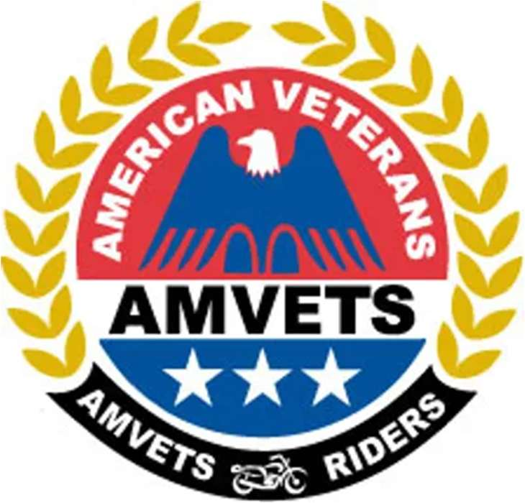
AMVETS RIDERS
SGT-AT-ARMS TRAINING GUIDE
“Riding in Service to Veterans”
Covers:
The 990 Compliance Process • Core Duties • Meeting Protocol & Authority • Colors & Ceremonial Duties • Uniform & Vest Enforcement • Entering & Verifying 990 Records • Revalidation Coordination • IRS Filing Deadlines • Form 990-N Q&A • Vest Guide • Readiness Checklist
Database: amvets-riders-database.web.app
Updated September 2026

1. The Current 990 Compliance Process
Do not mail or email 990 records — The old process of sending 990 copies from the Chapter to the Department, from the Department to National, or from the Sgt-at-Arms to the 1st Vice is discontinued. After the organization files with the IRS, the Chapter Sgt-at-Arms enters, verifies, and saves the filing information in the Compliance area of the AMVETS Riders Membership Database. The Department reviews and verifies the Chapter record, and National completes the final verification.
The database does not file the IRS return — The applicable Chapter or Department officer must first file Form 990, 990-EZ, or 990-N with the IRS. The AMVETS Riders database records and verifies that filing for organizational compliance.

Chapter compliance workflow
Step | Required action
1 | The Chapter files its required annual return or e-Postcard with the IRS.
2 | The Chapter Sgt-at-Arms opens the Compliance area in the Riders database.
3 | The Sgt-at-Arms selects the correct Chapter and tax-year filing cycle.
4 | The filing is checked through the IRS Tax-Exempt Organization Search or the IRS lookup available from the database.
5 | The form type, filing date, tax period, verification result, and any required notes are entered.
6 | The Chapter verification is saved in the database.
7 | The Department reviews and records Department verification when a Department exists.
8 | National reviews and records final verification.

If the Chapter does not have a Riders Department, its saved Chapter verification routes directly to National for final review. No copy is mailed, emailed, or sent to the 1st Vice.

2. Introduction and Core Duties
The purpose of this manual is to provide guidance, duties, and resources for the AMVETS Riders Sgt-at-Arms. This officer plays a critical role in maintaining order, discipline, safety, uniform standards, ceremonial respect, and 990 compliance records.

Duties of the Sgt-at-Arms
- Maintain order during meetings and official events.
- Enforce compliance with AMVETS Riders By-Laws and procedures.
- Protect AMVETS Riders property and assets.
- Coordinate security and safety for meetings, rides, and events.
- Ensure Riders follow official uniform and vest standards at meetings, events, and official functions.
- Carry out lawful instructions from the President or Executive Board.
- Ensure proper conduct and decorum of members and guests.
- Safeguard and properly handle the United States Flag and AMVETS Riders Flag.
- Enter, verify, and save the organization's annual 990 compliance information in the database at the appropriate level.
- Monitor Department or National verification status and correct incomplete records.

Standards for the role
Standard | Expectation
Professional | Exercise authority calmly, consistently, and respectfully.
Prepared | Know the agenda, meeting rules, safety plan, ceremonial duties, and compliance deadlines.
Impartial | Apply rules without favoritism and seek Judge Advocate guidance when needed.
Accurate | Confirm every database compliance entry is attached to the correct organization and filing cycle.
Accountable | Follow a task through Department and National verification rather than stopping after data entry.

3. Meeting Protocol, Authority, and Conduct

Before the meeting
- Inspect the meeting area and identify entrances, exits, and any safety concern.
- Verify attendance of members and guests.
- Ensure only authorized individuals remain once the meeting opens.
- Report attendance status to the President before the opening ceremony.
- Confirm the colors and ceremonial equipment are present and ready.

During the meeting
- Maintain order and proper decorum.
- Control access to the meeting when directed.
- Carry out the President's instructions consistent with the governing documents.
- Support the Judge Advocate when a procedural or disciplinary question arises.
- Intervene respectfully and use only the level of action necessary to restore order.

After the meeting
- Assist with closing procedures as directed.
- Confirm the colors and organizational property are secured.
- Ensure the meeting area is restored respectfully and appropriately.
- Document any security, conduct, or safety concern that leadership must address.

Authority and conduct
The Sgt-at-Arms serves as the President's representative for maintaining order. Authority must be exercised respectfully and professionally. A disciplinary concern should be handled calmly and in accordance with AMVETS Riders By-Laws and policies. Removal from a meeting should occur only when necessary and with the President's awareness, subject to the governing documents and immediate safety needs.

4. Colors, Ceremonial Duties, and Officer Coordination

Colors and ceremonial duties
The Sgt-at-Arms is responsible for the proper handling and care of the colors. Duties include:
- Ensure the flags are present, clean, and displayed correctly.
- Coordinate with designated color bearers when assigned.
- Oversee posting and retiring the colors during meetings and ceremonies.
- Ensure all flag handling follows proper respect and protocol.
- Store flags and ceremonial equipment safely after use.

Relationship with other officers
Officer | Coordinate on
President | Primary direction, authority, meeting order, and response to conduct issues.
Vice Presidents | Meeting support, attendance, member questions, and event operations.
Judge Advocate | Procedural and disciplinary guidance; interpretation of governing documents.
Chaplain | Ceremonial support and assistance when members or guests need care.
Secretary | Attendance, incident documentation, and official records.
Treasurer | Tax-year details and supporting information needed to confirm the annual filing.
Department/National Sgt-at-Arms | 990 compliance review, correction, and database verification.

Best practices
- Be familiar with the AMVETS Riders Constitution and By-Laws.
- Understand basic parliamentary procedure.
- Maintain professionalism under pressure.
- Communicate clearly and respectfully.
- Prepare for ceremonial and operational duties before members arrive.
- Keep 990 compliance records current rather than waiting for revalidation.

5. Uniform and Vest Enforcement
The Sgt-at-Arms is responsible for helping ensure members comply with official AMVETS Riders uniform standards. Corrections should be handled consistently, respectfully, and early enough for a member to comply before an official function.
Area | Requirement
Back of vest | Top and bottom rockers must touch the center patch with no gaps. No other patches are permitted on the back.
Front of vest | The United States Flag patch is placed highest over the heart. Officer identification bars go directly below as applicable.
Parent organization | Place the AMVETS parent organization patch in the authorized front position.
POW-MIA | Wear in the authorized upper-front position as shown in the vest guide.
Side panels | No side patches are permitted.
Attachment | All patches must be securely attached.
Consistency | Members should maintain a professional and consistent appearance.

Uniform enforcement approach
- Inspect discreetly and explain the exact rule that needs correction.
- Give the member a reasonable opportunity to correct the issue when circumstances permit.
- Apply the same standard to every member and officer.
- Ask the Judge Advocate or President for a ruling when the governing documents are unclear.
- Document repeated or disputed violations when leadership action may be required.
Use the governing standard — The photographs in this guide are placement examples. If an image and a current governing uniform rule differ, follow the current AMVETS Riders governing rule.

6. Entering a 990 Record in the Database
Use the Compliance area as the official AMVETS Riders record of the IRS filing and its verification status.
Step | Action
1. Sign in | Use the account assigned to the current Sgt-at-Arms or authorized compliance officer.
2. Open Compliance | Go to the Compliance or 990 area of the membership database.
3. Select organization | Confirm the correct state, Department, and Chapter. National officers must also check Chapters without a Department.
4. Select filing cycle | Choose the correct tax year or fiscal period. Do not overwrite a different year's record.
5. Verify with IRS | Use the IRS search link/button and confirm the EIN, organization name, filing type, tax period, and filing status.
6. Enter details | Record the form type, filing date, verified status, and any required note or extension information.
7. Save | Save the entry and wait for confirmation.
8. Reopen | Confirm the record is visible under the correct organization and that every field is accurate.

Required accuracy checks
- EIN belongs to the selected Chapter or Department.
- Legal organization name matches the IRS record closely enough to identify the correct organization.
- Tax year or fiscal period is correct.
- Form type is correct: 990, 990-EZ, or 990-N.
- Filing or acceptance date is correctly recorded.
- Chapter verification is saved before Department or National review.
Avoid duplicate or wrong-year entries — Search the database before creating a new record. If an incorrect record must be removed, contact the authorized administrator rather than creating additional entries to hide the mistake.

7. Department and National Verification

Department verification
- Open the pending Chapter compliance records for the Department.
- Confirm the Chapter, EIN, filing cycle, form type, and filing date.
- Use the IRS Tax-Exempt Organization Search to independently confirm the filing when available.
- If accurate, record Department verification in the database.
- If information is missing or incorrect, return it for correction through the database process or contact the Chapter. Do not accept an emailed copy as a substitute for correcting the database record.

National verification
- Review Department-verified records and records from Chapters without a Department.
- Confirm the selected organization and filing cycle are correct.
- Verify the filing through the IRS search source when available.
- Record final National verification in the database.
- Return incomplete or inaccurate records for correction through the database workflow.

Completion by organization level
Organization | First step | Review | Final
Chapter with Department | Chapter Verified | Department Verified | National Verified
Chapter without Department | Chapter Verified | Not applicable | National Verified
Department filing | Not applicable | Department record saved | National Verified

A saved entry is not always complete — The record is complete only when all verification levels that apply to the organization are visible. The Sgt-at-Arms should monitor the record until National verification is complete.

8. Revalidation Coordination and Annual Schedule
The 990 filing and the AMVETS Riders revalidation are separate requirements. Complete the IRS filing by its IRS due date, then make sure the filing is recorded and verified in the database in time for Riders revalidation.
When | Action
After the tax year ends | Confirm which return is required and the IRS due date.
After IRS filing | Enter and verify the filing in the database immediately.
Before Chapter revalidation | Confirm Chapter, Department when applicable, and National verification status. Chapter revalidation is due July 1.
July 2 at 12:02 AM | A Chapter missing required revalidation may be automatically suspended under the Riders deadline stated in the 2026 guides.
Before Department revalidation | Confirm the Department filing record and Chapter compliance records are current. Department revalidation is due July 15.
July 16 at 12:02 AM | A Department missing required revalidation may be automatically suspended under the Riders deadline stated in the 2026 guides.
Officer transition | Outgoing and incoming Sgt-at-Arms review open compliance items and database access together.

Revalidation check
- Do not attach or mail a 990 copy with a revalidation form.
- Do not send 990 copies to the Department, National, or 1st Vice.
- Confirm the database record is under the correct filing year and organization.
- Confirm the required Chapter, Department, and National verification indicators are saved.
- Resolve any rejected or incomplete record before the applicable revalidation deadline.

9. IRS Form 990 Filing Deadlines and Extensions
The IRS generally requires Form 990, 990-EZ, or 990-N by the 15th day of the fifth month after the organization's tax year ends. If that date falls on a Saturday, Sunday, or legal holiday, the due date moves to the next business day.
Tax year ends | Typical IRS due date
December 31 | May 15 of the following year
June 30 | November 15 of the same year

Extension rules
Filing | Extension rule
Form 990 or 990-EZ | Form 8868 may be used to request an automatic six-month extension when filed on time.
Form 990-N | The due date cannot be extended with Form 8868.

Failure to file
Failure to file a required annual return or notice for three consecutive years results in automatic revocation of federal tax-exempt status. A late Form 990-N generally does not carry a monetary penalty, but the three-year automatic-revocation rule still applies. Other 990-series returns may be subject to late-filing consequences.
Important correction from the prior guide — The six-month Form 8868 extension does not apply to Form 990-N. It applies to eligible returns such as Form 990 and Form 990-EZ. The database should accurately identify the filing type before any extension is recorded.

Official IRS references
IRS: Annual exempt organization return due date
IRS: Form 990-N (e-Postcard)
IRS: About Form 8868
IRS rules can change. Confirm the filing requirement with the current IRS instructions or a qualified tax professional.

10. Appendix A – Filing Form 990-N: Questions and Answers

How is Form 990-N filed?
Form 990-N is filed electronically with the IRS. There is no paper Form 990-N. Complete the IRS filing before entering the verification record in the AMVETS Riders database.

Who may be eligible to file Form 990-N?
Most small tax-exempt organizations whose annual gross receipts are normally $50,000 or less may be eligible, subject to IRS rules and exceptions. Confirm eligibility using current IRS guidance.

When is it due?
It is due annually by the 15th day of the fifth month after the close of the tax year. The e-Postcard cannot be filed until the tax year has ended.

How is the tax year determined?
A calendar tax year is January 1 through December 31. A fiscal tax year is a 12-month period ending on the last day of a month other than December. Check the organization's governing documents, exemption records, IRS filings, or tax professional guidance.

Can Form 990-N receive a six-month extension?
No. Form 8868 cannot extend the Form 990-N due date.

Where tax-year information may be found
- The organization's By-Laws or other governing documents.
- The exemption application or determination letter.
- Formation documents, such as articles and the EIN record.
- A prior Form 990, 990-EZ, or 990-N filing.

11. Appendix A – Form 990-N Information and Verification

Information commonly needed for Form 990-N
 | Information
1 | Employer identification number (EIN).
2 | Tax year.
3 | Legal name and mailing address.
4 | Other names the organization uses.
5 | Name and address of a principal officer. Use the official organization or Post address when appropriate and consistent with IRS records, not an officer's personal address merely for convenience.
6 | Website address, if the organization has one.
7 | Confirmation that annual gross receipts are normally $50,000 or less, when applicable.
8 | A statement regarding termination or going out of business, when applicable.

How to locate and verify prior filings
- Open the IRS Tax-Exempt Organization Search.
- Search using the organization's EIN whenever possible.
- Confirm the legal name, state, filing type, and tax period.
- Compare the IRS result with the Chapter or Department selected in the Riders database.
- Enter the result and save the appropriate verification status in the Compliance area.
IRS Tax-Exempt Organization Search
AMVETS Riders Membership Database
Do not rely on a screenshot alone — Use the IRS result to verify the correct organization, then save the actual compliance details in the database. A screenshot or emailed copy is not the official Riders verification record.

12. Appendix B – AMVETS Riders Vest Guide: Front

Front of vest
- United States Flag patch: over the heart and at the highest elevation on the front.
- Officer identification bars: directly below the flag as applicable.
- AMVETS parent organization patch: authorized right-chest position.
- POW-MIA patch: authorized upper-front position, above the parent organization hat patch when that patch is worn.
- No side patches are permitted.
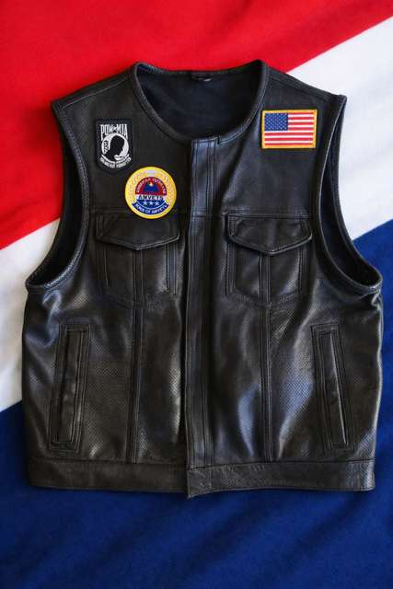
Placement example – follow the current governing uniform standard.

13. Appendix B – AMVETS Riders Vest Guide: Back

Back of vest
- Top rocker: sewn directly above and touching the center patch.
- Center patch: official AMVETS Riders emblem in an authorized size.
- Bottom rocker: sewn directly below and touching the center patch.
- Rockers must touch the center patch with no gaps.
- No other patches are permitted on the back.
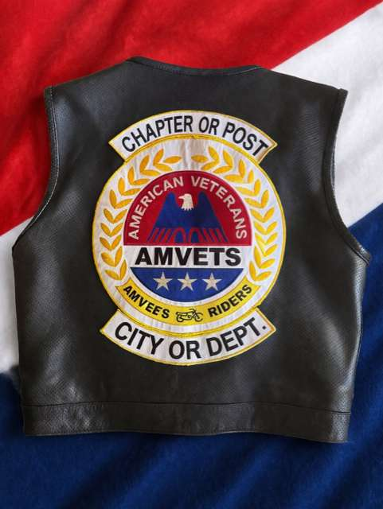
Placement example – Chapter/Post and City/Department rockers are shown as placeholders.

14. Practical Guidance and Readiness Checklist

Meeting protocols and order maintenance
- Arrive early and inspect the room, entrances, colors, and ceremonial equipment.
- Know the expected attendance, guests, agenda, and any sensitive business.
- Use calm verbal direction first whenever circumstances allow.
- Ask the President or Judge Advocate for guidance before escalating a non-emergency dispute.

Conflict resolution and member discipline
- Separate behavior from personality and apply the same standard to everyone.
- State the rule, request compliance, and document what occurred when necessary.
- Protect due process and confidentiality.
- Use immediate safety action when a person or property is at risk.

Event security and safety
- Confirm the event point of contact, emergency plan, route responsibilities, and staging area.
- Identify local emergency services and safe evacuation routes.
- Coordinate volunteers and communicate changes clearly.
- Report incidents promptly through the appropriate chain of command.

Annual readiness checklist
 | Check
[ ] | Current governing documents reviewed.
[ ] | Meeting and ceremonial responsibilities understood.
[ ] | Uniform and vest standards reviewed with members.
[ ] | Current 990 filing cycle identified.
[ ] | IRS filing independently verified.
[ ] | Chapter or Department compliance record saved in database.
[ ] | Department verification completed when applicable.
[ ] | National final verification completed.
[ ] | Open issues transferred to the incoming Sgt-at-Arms.

15. Closing and Call to Action
The Sgt-at-Arms protects order, safety, tradition, and compliance.
Professional execution of meeting, ceremonial, uniform, security, and database responsibilities supports effective leadership and reflects positively on the AMVETS Riders at every level.
Final 990 reminder — File with the IRS first. Then enter, verify, and save the filing in the AMVETS Riders database. Department reviews Chapter records when applicable, and National completes final verification. Do not mail or email copies to the Department, National, or the 1st Vice.
Loyalty – Respect – Brotherhood

