AMVETS RIDERS

AMVETS Riders Vest Patch Placement Guide
Front and Back Placement Standards
This guide shows the authorized placement of patches and rockers on the AMVETS Riders vest. Placement must follow the current governing uniform standard.

Front of Vest
- United States Flag patch: over the heart and at the highest elevation on the front.
- Officer identification bars: directly below the flag as applicable.
- AMVETS parent organization patch: authorized right-chest position.
- POW-MIA patch: authorized upper-front position, above the parent organization hat patch when that patch is worn.
- No side patches are permitted.
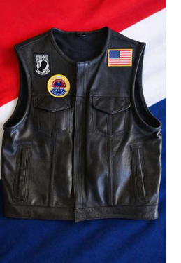
Placement example - follow the current governing uniform standard.

Back of Vest
- Top rocker: sewn directly above and touching the center patch.
- Center patch: official AMVETS Riders emblem in an authorized size.
- Bottom rocker: sewn directly below and touching the center patch.
- Rockers must touch the center patch with no gaps.
- No other patches are permitted on the back.
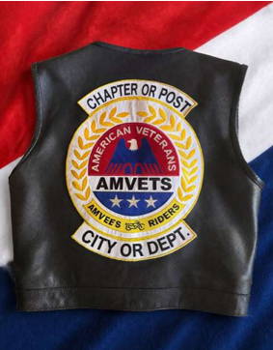
Placement example - Chapter/Post and City/Department rockers are shown as placeholders.

